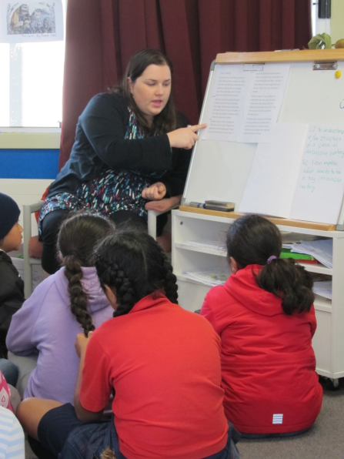
Associate teachers are a central part of teacher preparation. Without associate teachers our aspiring teachers cannot experience what it is to be a teacher and improve their ability to teach in ways that improve outcomes for all learners. Associate teachers are more than hosts or authorities. They are educative mentors. Educative mentors build knowledge, skills and understandings by working alongside student teachers, observing, reflecting, questioning and guiding. Working with another adult as well as your class can be challenging, but it is a task that is critical for the teaching profession. We thank you for considering taking it on.
The role of associate teacher involves:
- Creating opportunities for a student to meet the specific requirements of the practicum (taking into account the student’s stage of development)
- Providing opportunities for the student to observe, teach and discuss the classroom programme
- Allowing students to try out new ideas, to reflect upon their practice and to be actively involved in their own learning (teaching as inquiry model)
- Negotiating assigned times outside of regular hours for regular discussions related to the practicum and the student’s progress
- Giving clear and specific oral and written feedback on the student’s teaching

Essential Characteristics to build student competence and capacity
Practical Considerations | Mentoring Considerations
Know the expectations of the practicum prior to it starting  Value the student teacher e.g.  - Provide a work space  - Present them to the class and school  - Acknowledge them as an emerging teacher  Have important paper work copied and available e.g.  - Timetables  - School organisation and meetings  - Long term / Weekly plan  Organise a tour of the school to highlight key areas and resource spaces  Arrange regular meeting times for professional conversations | Model effective planning, practice, assessment and reflection  - Learning focussed  - Differentiated / Inclusive  Engage in regular serious professional conversations  - Evidence based  - Challenges pedagogy  - Focussed and specific  Provide oral and written feedback  and feed forward from planned and  incidental observations  Develop student teacher autonomy  - Allow different teaching styles  - Encourage the development of own behaviour management systems  - Provide specific support and guidance with lesson planning, development of resources and assessment requirements

Timothy Bannister, Glen Eden Intermediate, 2013

Associate Teachers play a vital role in the Practicum placements of the Bachelor of Education (Teaching) Primary Specialisation programme. The work and thought that goes into supporting our student teachers is paramount and very much appreciated.

Useful links/resources that support the BEd (Tchg) Pry Programme:
https://practicum-hub.blogs.auckland.ac.nz/
https://teachingcouncil.nz/sites/default/files/Guidelines%20for%20Induction%20English%20web.pdf

References:
- Professional Learning Journeys “ Guidelines for Induction and Mentoring and Mentor Teachers 2011” (Teaching Council)
To contact the Practicum office:
- Ph: 623 8899

The information in this pamphlet was prepared in 2013 by a group of Adjunct and University Liaison Lecturers for Associate Teachers. Last updated: 2019
Produced by: Isabel Browne (University of Auckland), Fiona Ell (University of Auckland), Virginia Kung (Newmarket School), Gail Ledger (University of Auckland), Phil Spriggs (Helensville Primary School), Mandy Vanderwee (Konini School).

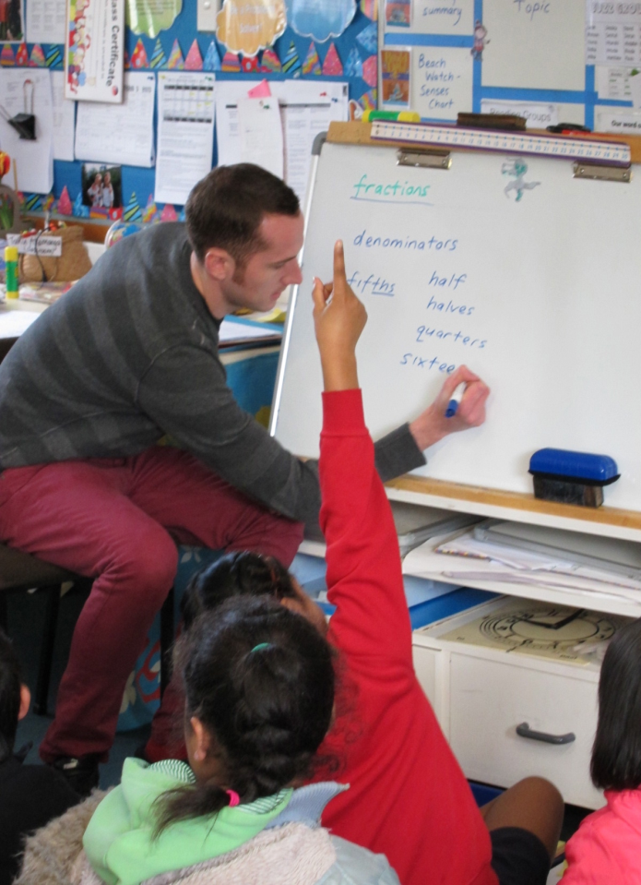
The Role of the Associate Teacher

The mediocre teacher tells.
The good teacher explains.

The superior teacher demonstrates.
The great teacher inspires.
William Arthur Ward

